Gas Chromatography
Gas Chromatography (GC) is used to separate volatile components of a mixture. A small amount of the sample to be analyzed is drawn up into a syringe. The syringe needle is placed into a hot injector port of the gas chromatograph, and the sample is injected. The injector is set to a temperature higher than the components’ boiling points. So, components of the mixture evaporate into the gas phase inside the injector. A carrier gas, such as helium, flows through the injector and pushes the gaseous components of the sample onto the GC column. It is within the column that separation of the components takes place. Molecules partition between the carrier gas (the mobile phase) and the high boiling liquid (the stationary phase) within the GC column.
Top View of Oven and Columns  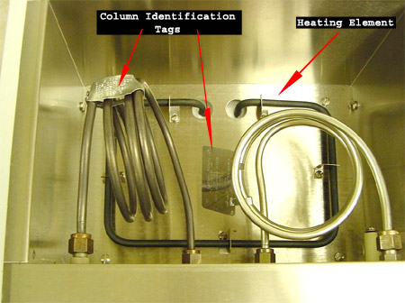 | Two columns will fit inside the oven of our GCs. A heating element is used to raise the oven temperature, when desired, and thus raise the column temperature. GC columns typically have a metal identification tag clipped onto the column that lists column length and diameter, what material is inside, and the maximum operating temperature.
After components of the mixture move through the GC column, they reach a detector. Ideally, components of the mixture will reach the detector at varying times due to differences in the partitioning between mobile and stationary phases. The detector sends a signal to the chart recorder which results in a peak on the chart paper. The area of the peak is proportional to the number of molecules generating the signal.
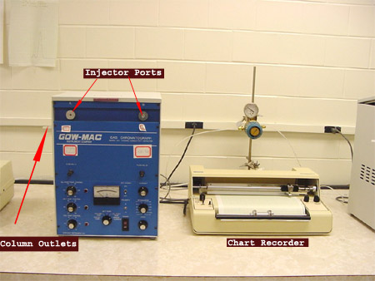
To use the GC, follow these simple steps:
1. Wash a syringe with acetone by filling the syringe completely and ejecting the waste acetone onto a paper towel. Wash 2-3 times.
2. Pull some of your sample into the syringe. You will most likely need to remove air bubbles in the syringe by rapidly moving the plunger up and down while the needle is in the sample. Usually 1-2 μL of sample is injected into the GC. It is okay to have small air bubbles in the syringe. However, you do not want to inject mostly air or your peaks will be too small on the chart recorder.
3. Make sure the chart recorder is on and set to the appropriate chart speed (Arrow A). Set the baseline using the zero on the chart recorder (Arrow B). With the pen in place, turn on the chart (Arrow D), make sure the pen is down (marking the paper) and the paper is moving.
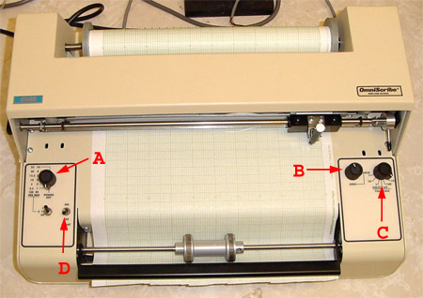 | Arrow A | Set chart speed in cm/min
 | Arrow B | Set zero so that the baseline is ~ 1 cm from bottom (right edge) of chart paper
 | Arrow C | Record (but do not adjust) full scale setting
 | Arrow D | Switch to turn movement of chart paper on and off.
4. Inject your sample onto either column A or column B as instructed. Hold the syringe level and push the needle completely into the injector. Once you can no longer see the needle, quickly push the plunger and then pull the syringe out of the injection port.
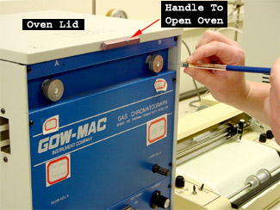 | 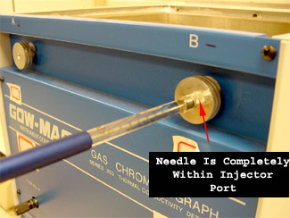

Injection Notes:
A) | The injectors are very hot, so be careful not to touch the silver disk.
B) | The needle will pass through a rubber septum, so you should feel some resistance. For some of our GC’s, the column does not align properly in the injector, so the needle hits the front of the metal column. If you feel that you are pushing against metal, pull the needle out of the injector and try again, perhaps at a slightly different angle. The needle should completely disappear into the injector for proper injection of the sample onto the GC column.
C) | Inject quickly for best results. Do not hesitate to inject once the needle is properly positioned in the injection port.
D) | Remove the syringe immediately after injection. (Carrying out notes C and D helps to insure that all of the sample enters the GC column at approximately the same time.)
5. Mark your injection time on the chart recorder. This can be done by adjusting the zero just after the sample is injected. It is often convenient for one person to inject the sample while a lab partner marks the injection time at the chart recorder.
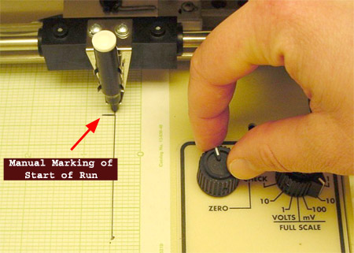
6. Clean your syringe immediately after injection. Syringe needles often clog quickly and must be replaced if they are not cleaned after each use.
7. Record the settings of your chart recorder during a run. You need to know the chart speed and the full-scale setting.
8. Record the settings of your GC during a run. A knob on the bottom center of the GC can be turned to read column (or oven) temperature, detector temperature, and injector port temperature in °C. The bridge current is displayed in mA. Note that there are two scales on the display. Be careful to read the appropriate scale!
 | Arrow A | Top scale is reported in milliamps and is used to read the bridge current.
 | Arrow B | Bottom scale is reported in degrees Celsius and is used to read all temperatures.
 | Arrow C | Typically the ONLY knob to be adjusted by students. Knob is turned for corresponding reading on the scale above the knob.
 | Arrow D | Increasing the Attenuator setting decreases the area of a peak on the chart recorder. This knob should only be adjusted with permission of instructor. Always return the knob to its original setting if you are given permission to change it.

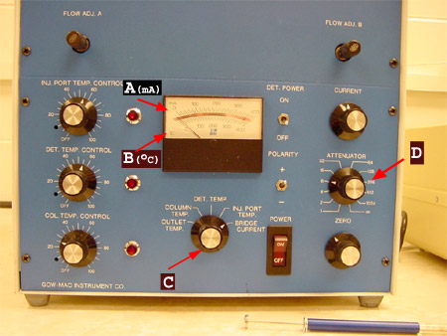

Analysis of the Gas Chromatograph
Report the retention time of each peak (in minutes), the identity of each component in the mixture, and the percent composition of the mixture. To determine the percent composition, you will first need to find the area under each curve.
Area = (height) x (width at ½ height)
Mark retention time, height, half-height, and width at ½ height on your GC trace. Show your calculations either in your final report or directly on the chromatograph.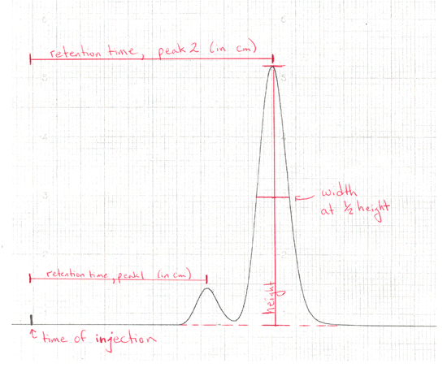
You may assume that each component of the mixture causes the same response in the detector. Therefore, the areas under the curves can be used to calculate percent composition of the mixture of alkenes. (This is a reasonable assumption when the components of the mixture are very similar in structure, as are 2-methyl-1-butene and 2-methyl-2-butene.)
% Component 1 = [(area under peak 1)/(total area)] x 100%
The sample used to obtain the GC trace that is shown above did not have any solvent in it. Student samples will have at least one solvent present, so you will see another peak in your GC traces that typically appears very soon (usually within a minute) after injection. It is normal for the solvent peak to go off scale.

FTIR
Infrared Spectrocopy
Infrared (IR) light or radiation has the correct energy to enhance stretching and bending of bonds, which are vibrational transitions. Because molecules have many possible vibrational states, each with a slightly different energy and thus a different frequency of radiation required to enhance the vibration, many absorption bands appear in the infrared spectra of even the simplest molecules. Today, infrared spectroscopy is typically used to identify the presence of functional groups.
IR spectra can be obtained on solids, liquids, and gases. Our organic students typically analyze only liquid samples. The department owns two Fourier transform infrared (FT-IR) spectrometers that are located in Salem 104. Both spectrometers are controlled through a windows based program called WinFirst.
Galaxy FT-IR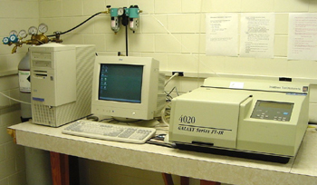 | Genesis FT-IR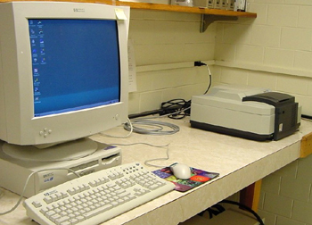

To use the IR, follow these simple steps:  Preparing a sample:  1. Obtain two salt plates from a desiccator. To open the desiccator, slide off the lid. Do not attempt to remove the lid by pulling straight up on it. (Please keep the desiccator closed as much as possible.)  2. Clean the plates with an organic solvent such as acetone. Since the plates are made of salt (usually KBr), never wash the salt plates with water. Place the plates on a Kimwipe, cover the plate with acetone, and then gently wipe the plate with a Kimwipe. Clean both sides. (Handle plates only on the edges to avoid obtaining an IR spectrum of oils from your fingers.) | 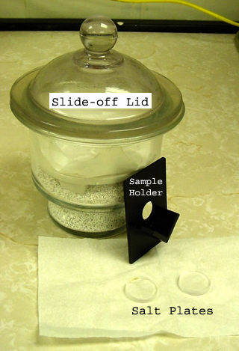

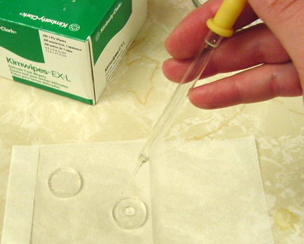 | 3. Once the acetone has evaporated from the plates, add one drop of your sample to one plate. Place the second plate on top of the first to sandwich your sample between the two salt plates.  4. If a salt plate sample holder is not installed inside the IR spectrometer, slide one into place. (The holder will only fit in one of the two available tracks.) Place your sample into the holder and close the IR compartment.

Placing samples inside IR:  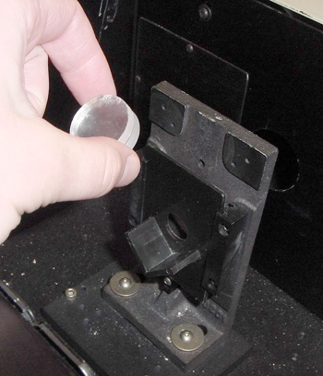  The holes in the sample holder and instrument side panels align to allow light to pass from the IR source through the sample, and then to the detector. | Genesis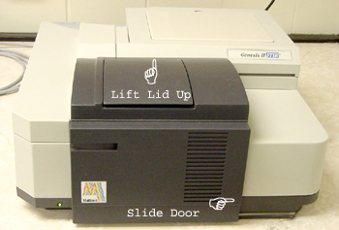  Galaxy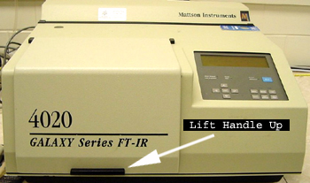
Obtaining a spectrum:
5. Open the IR software by double-clicking the “Start IR” icon if it is not already open. (Be careful not to open the software using the WinFIRST icon. You cannot scan new samples unless you open the software from the Start IR icon.)
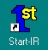 | Use this icon to scan a new sample or recall one saved previously. |  | This icon should only be used to recall a spectrum you saved previously.
6. Click the “Simple Menus” button at the lower right corner of the screen.
7. IF you are instructed to use a particular method, use the “Scan” dropdown menu and select “Scan Method.” Select the desired method.
8. Use the dropdown menus to carry out the following tasks (in order):
a. Scan: Background Scan Make sure the light path is clear (no sample or salt plates in IR) while obtaining the background. (“100% Complete” appears in the bottom right corner when background scan is complete.)
b. Scan: Sample Scan (Spectrum appears on screen when complete.)
c. Math: Autobaseline (Sometimes performing an autobaseline calculation multiple times is necessary to make the spectrum baseline look reasonable.)
d. Math: Peaks (select singles and “OK”) Click at the bottom of an absorbance and the wavenumber of that absorbance will appear on your spectrum. However, if the peak is full scale, then it will not be possible to read the wavenumber when it prints. (If you can't read the label on the screen, you won't be able to read the label in the printout.)
e. To label full-scale peaks: If the “Notate” window is not open, then open it using the dropdown menu “Tools-Annotator.” Click the second icon, top row in the Notate window. A box should pop up instructing you to “Pick Two Points.” First click at the bottom of the peak you want to label and then click in an open space where you want the text box to appear. Repeat as necessary. | 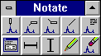
f. To edit text: Double-click on the title and alter the text to include at least your name. The top right icon in the Notate box allows you to type text on the spectrum. The pencil icon allows you to edit text lines in the spectrum. The pencil eraser icon in the Notate window clears all peak labels.
g. File: Plot Select the Salem 104 printer, click “Plot” and then “Done.”
Posted on the wall near each IR is a “frequently encountered problems” sheet. If you have trouble, first see if the solution is posted on that sheet.
Saving a spectrum:
9. There are several formats in which you can save the data from the “File – Save As” menu. If you save to the hard drive, please use your WFU username as the filename to avoid confusion, and save in a course-titled folder (such as Chm223L.)
- If you want to be able to open the spectrum again in WinFirst, choose “Mattson Data File.” You may save one copy of your spectrum in a course folder. The file path on the Galaxy, for example, is C:/First/Data/Galaxy/Chm223L/.
- You may save to a floppy disk and open the spectrum in WinFirst on any networked Wake Forest computer by following the instructions listed on the linked web page.
- Data may be exported to Microsoft Excel and many other graphing programs as an ASCII Table. When opening the file in Excel, check “Space” as a delimiter to get wavenumbers and absorbencies in separate columns.
- To use Dr. Bell’s IR program, save the file to the A drive as “SpectraCalc & GRAMS.”
Cleaning up:
10. Clean your plates with acetone or ethanol (NEVER water!) and place them back in the desiccator. Throw away any used Kimwipes and place disposable pipets in a broken glass container.

TLC
Thin Layer Chromatography (TLC) is a powerful technique to separate compounds based upon their polarity and interaction with silica and to assess the purifty of a sample. To perform TLC, a solution of a compound or mixture of compounds is applied to a TLC plate by using a thin capillary tube. First, make a thin pencil mark on your TLC plate about one-quarter of an inch up from one end. Dip the capillary tube into the solution of compound and then touch the tube onto the line on your TLC plate. Now place they plate into a developing chamber (can be a simple beaker with some filter paper and aluminun foil cover). The developing chamber should have some developing solvent in it but the level of this solvent should not be above the pencil mark on your plate. Allow the solvent to move up the TLC plate and remove the plate when the solvent nearly reaches the top. Mark the distance as to where the solvent traveled. Now visualize your plate by first noting any spots you can visually see, then spots you can see with the aid of an ultraviolet light source, and then lastly by adding your plate to an iodine chamber. Once your spots have been visualized you can calculate the Rf value of each, the Rf value is also a physical constant of an organic molecule.
This procedure is shown below.
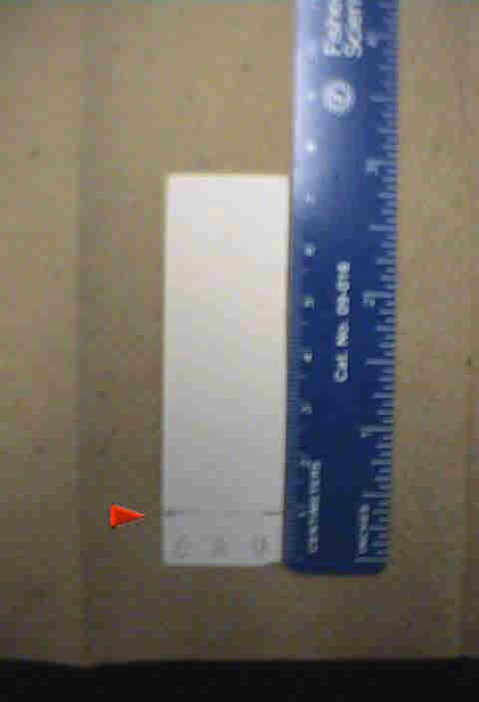
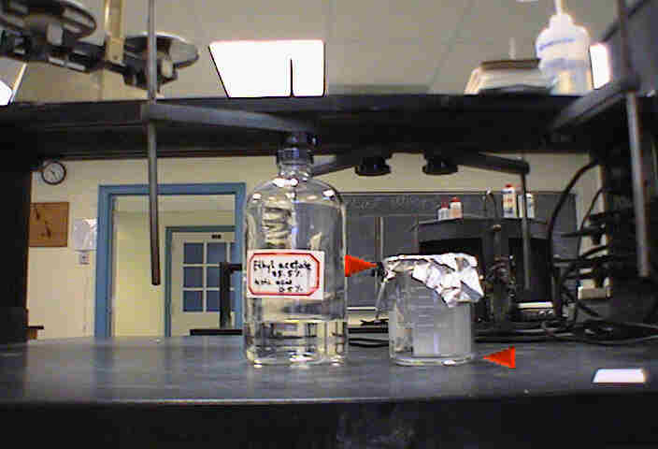
Pictured at the left is a TLC plate. The white matte surface pictured is the solid phase of this chromotography procedure. The solid line on the plate is drawn one centimeter from the bottom of the plate IN PENCIL. This is the line on which the the sample is applied. The lables from left to right read C, A, and U, represent caffine, asprin, and the unknown.
The chamber in which TLC takes place is filled to less than one centimeter of solvent (ethyl acetate and acetic acid). It is extremely important that the solvent in the developing chamber be filled to LESS THAN ONE CM because the solvent must be drawn upward through the sample in order to draw the sample along with it. If the sample is dipped in to the solvent, it will damage the results. A piece of filter paper is placed in the chamber to draw the solvent into the top of the chamber. Finally it is important to cover the chamber to be sure that the solvent does not evaporate.

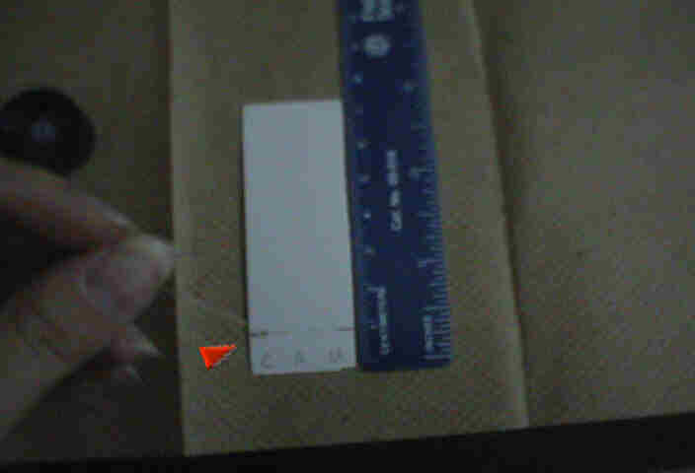
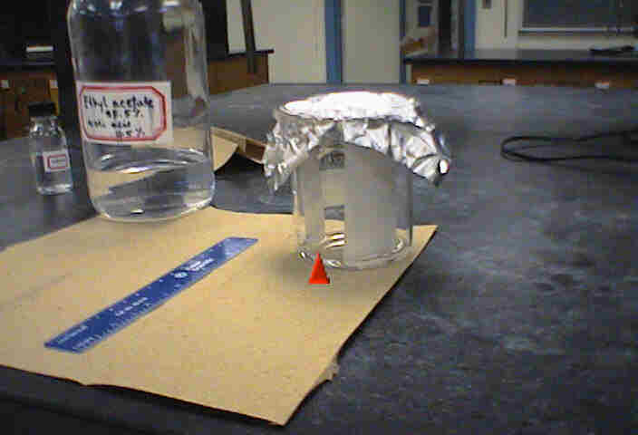
The samples are applied to the TLC plate with a capillary tube. To draw sample into the tube, heat the one end of the tube on a hot plate and then dip the cool end into the sample. This will draw the sample up into the tube. Then spot a small amount of sample onto the TLC plate as pictured at the left. Note that the sample is applied on the 1cm line.
After all samples are loaded, the plate can be placed in to the chamber. Be sure that the solvent is below the line on which the samples were applied and that the plate is not touching the filter paper. Also, keep an eye on the plate. It only takes a few minutes for the solvent to travel up the plate. When the solvent reaches approximately one centimeter below the end of the plate, remove it from the chamber. Be sure that the plate does not touch the filter paper.

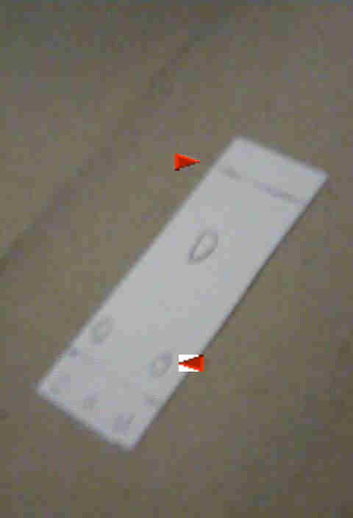
As soon as the plate is removed from the chamber, mark the solvent front for later calculations (top arrow). Allow the plate to dry. After the plate is dried, two methods can be used to visualize the location of the sample on the plate. Ultraviolet light can be used. When UV is used, the area of the plate surrounding the solvent will appear fluorsecent, while the solvent does not. Another way to visualize the sample is using an iodine chamber. Placing a few pieces of iodine in a covered container and then adding the plate will turn some samples brown. In either case, using a pencil outline the location of the sample for later calculations (bottom arrow). These calculations are shown below.

Rf is calculated as shown.
